**Team SPOTLIGHT**

**Stage 1: Empathize**

# **Project Briefing:**

Team Spotlight held a meeting with the client this month on August 24, 2022. Time of meeting is 2:00 PM to 3:00 PM. The meeting agenda is as follows:

* Project Updates
* Client Suggestions
* Low fidelity
* Future Implementations
* Paper Updates / Revisions

The team and client have successfully aligned the goals and delivered their desired agendas for the meeting. The team has also interviewed and checked up on the client’s situation regarding the new setup of their business.

The team agreed to adjust the clients need depending on the situation and client’s suggestions.

As the client shared their insight and struggles during the meeting, the team decided to make a map where the advisers, consultants, client, and instructor can understand the situation that troubles the client.

# **Project Team Questions:**

Here are the questions that the team prepared for the client; some of these were asked in person, while others were online.

1. What is the difference between the struggles you have faced from the business during and Hyflex setup of your business?
2. What do you usually do if you are at school during this Hyflex setup?
3. When do you usually check your accounting records and the status of the business?
4. Who is currently managing the business?
5. Where do you usually entertain the client during the pandemic and Hyflex setup?
6. Why do you think that this project can be beneficial to you?

# **Client Meeting Update:**

* The team share the updated low fidelity of the project.
  + The client approved the low fidelity and no suggestions for now.
  + Client Said: “*Tuloy lang yung project and improve lang yung development*” – Neil (Client proxy)
* The team will now introduce the prototype and core process of the project by the next meeting or quarter of the month.

# **Client Briefing:**

As the Client shares their struggles, developments and insights to their business flow, the team have decided to ask more questions that can be used to improve the paper and the overall project.

The client shares their insights by giving us the flow of their business:

|  |  |
| --- | --- |
| During pandemic | During Hyflex |
| Multiple staff | Reduced staff due to one of the members having classes |
| Consistent in processing of orders | Reduced consistency in terms of processing orders |
| Moderate sales | Stagnant sales |
| Less product stocks due to demand | Increase of product stocks due to lack of orders |

As you can see from the visual presentation, there are still struggles and minor changes from the business setup that is why project Akbay is believed, to still be relevant to deploy since all the features are connected to the client’s problem and can provide better solution for the project.

# **Client**

**Client Empathy Map**

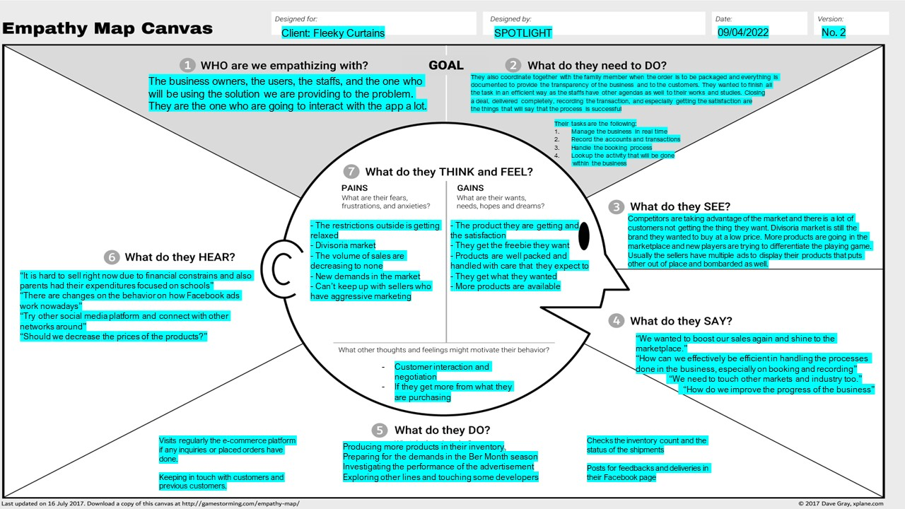

Show above is the client Empathy. This will help the team to proceed to stage 2 and identify all the key problems of the client.

Client Profile:

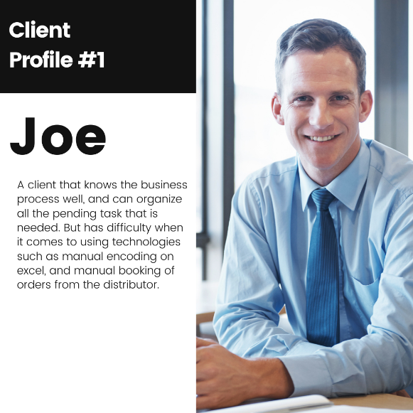

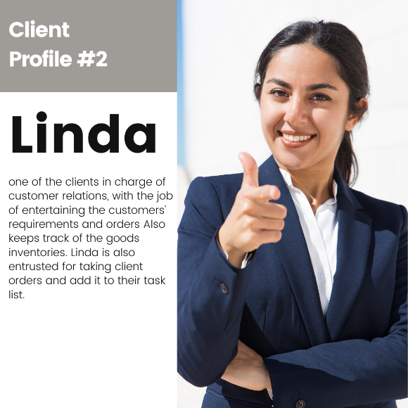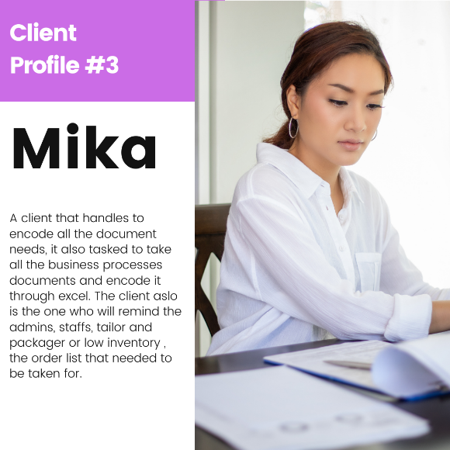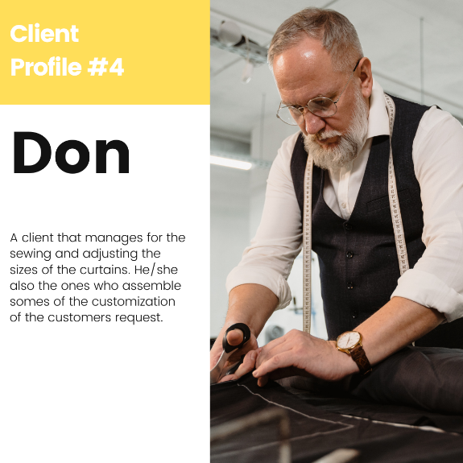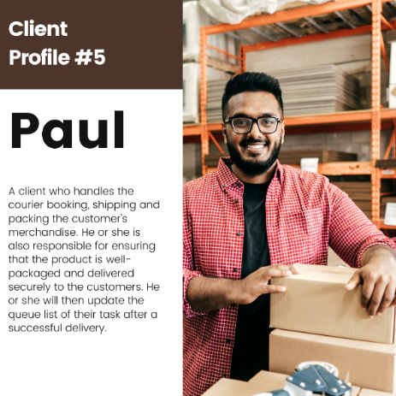

Shown above are the Client’s profile. Every profile has different task and role to their company. In this section it will help the team to identity the roles of every client’s employee.

# **Customer:**

**The Empathy Map:**

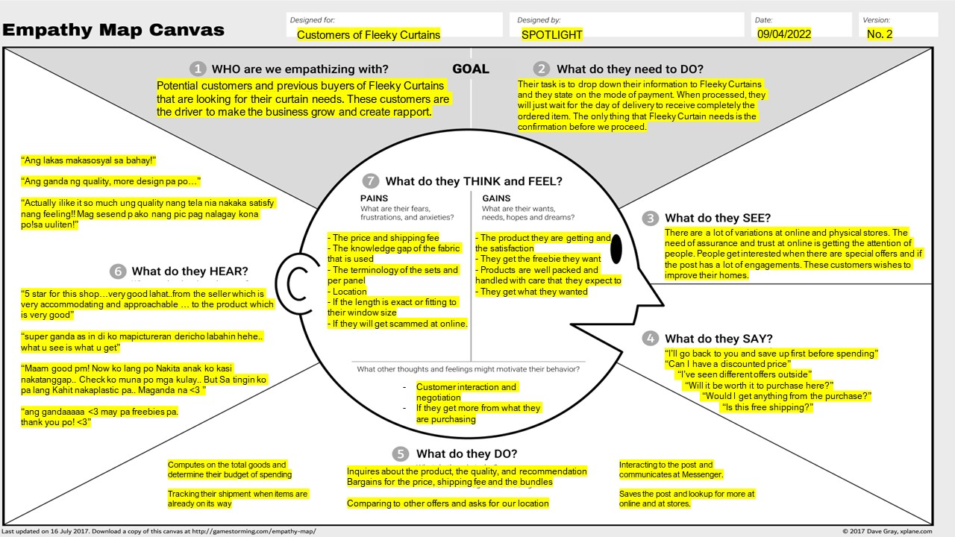

As we finalized the interview, the team made an empathy map that can be used as a reference to implement a better project. This diagram can help the team provide a solution that the client struggles with. It also highlights the risk and opportunities the business has.

**Pain and Gains:**

With the help of the interview and empathy map, the team provided a pain and gain analysis that displays the pain and gains of the customer. The diagram above helps us understand the pain points of the client’s business process when it comes to handling client and customer interaction.

**Customer Profile:**

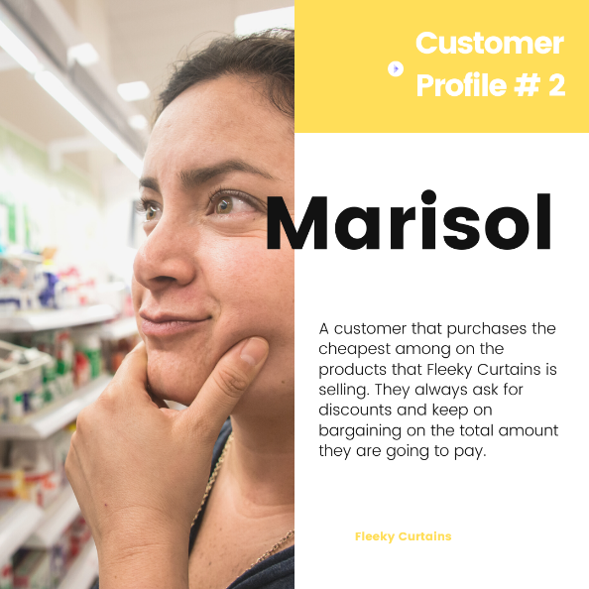

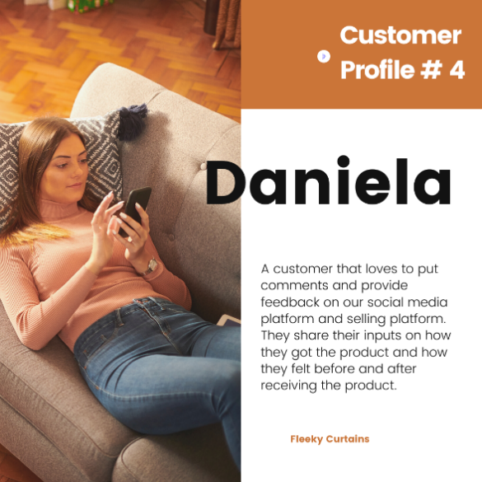

With the help of interview, the client shares a lot of insights of how the client’s employees work and strategize their business processes. The team spotlight has provided customer profiles where it will serve as a reference that is connected to the client’s information. After gathering and understanding the core process of the clients, the team will proceed to Stage 2 which is *define*. For the next project stage, the team will now highlight and define the best strategy and implementation that team spotlight can offer for Fleeky curtains.